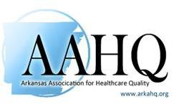  SAVE THE DATE  ocTOBER 27, 2017  FALL EDUCATION CONFERENCE  - Quality across the Healthcare Continuum: Putting the Pieces Together | FALL EDUCATION CONFERENCE  October 27, 2017  J.A. Gilbreath Conference Center  Baptist Medical Center 9601 Baptist Health Drive Little Rock, AR 72205  Learn from leaders in healthcare quality and network with other professionals around Arkansas  Arkansas Association for Healthcare Quality  For More information please visit our website at  www.arkahq.org  Telephone: (501) 224-7878  Fax: 501-224-0519

